Workshop on climate goals

October 9 th
The ambition of this workshop is to exchange ideas and be inspired.
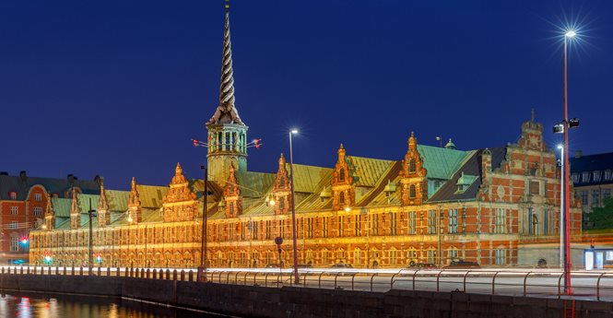
Several European countries will present their climate goals.
Danish and foreign students will make a presentation of some of their innovative projects and ideas. In addition, we will try to make some common conclusions on this crucial matter.
Agenda
13:00
Welcome to this 17th century house where we are DAKOFO’s guests. Introduction to the afternoon by Bo Degnbol Nielsen, Chairman of Danish Agronomists and Frederik Larsen, representing Think Tank Frej, and by agronomist students.
13:15
Presentation of climate problems and solutions from different CEDIA members
• Greece
• Spain
• Ireland
• Scandinavia
14:30 Questions to the speakers and discussion
14:45 Coffee and “Wienerbrød”
15:00 Presentation of Frej, working methods and results related to climate goals. Presentation of different students’ projects
16:00 Group discussions
16.30 Presentation of group viewpoints
17.00 Goodbye
Participation price:
Members of JA: DKK 0,00
Not a member of JA: DKK 250,00
Access is free for all students
Registration:
Members of JA sign up by using the "Tilmeld"-button. If you are not a member of JA or a student you sign up by sending an email to Cathrine Norup and inform about name and address to where the invoice should be send and issued.
If you have questions, you are welcome to contact Bo Degnbol, Chairman of the Board in the Danish Agronomist Association at phone number 2467 6138.
Kind regards
Dansk Agronomforening

