CEDIA-Workshop “Renewal Process”, June 27, 2018, Berlin

Objectives
- Strong mission statement for CEDIA based on common needs of member associations
- Mode of operation to run CEDIA taking into account the available resources
- Draft of the renewed articles in the statutes (last modified in 2002)
- Requirement profile for the future members of the executive board
- Plan of Action with the budget for 2018 and 2019
Participating member associations and participants
Denmark (JA)
- Bo Degnbol Nielsen, Chairman of the Danish Agronomist Association
- Hans-Henrik Jørgensen
- Elba Lorentzen
- Jacob Neergaard
Germany (VDL)
- Stephan Ludewig (Secretary of VDL)
- Rolf Schwerdtfeger (Vice-President VDL)
Ireland (ASA)
- Sean Gaule, President CEDIA
Spain(CGCOIA)
- Aguilella Joaquin (delegate of Baldomero Garcia de Rio, President of CGCOIA)
Switzerland (SVIAL)
- Ulrico Feitknecht
Apologized member associations
- Austria
- Belgium
- Cyprus
- Greece
- Italy
- Sweden
Moderator
Michel Roux, MRiX Projektmanagement und Moderation GmbH (www.mrix.ch)

Program
08:30 | Welcome and opening the workshop
 | - Welcome in the name of VDL | Ralf Schwerdtfeger
 | - Cedia today with al look at its history | Sean Gaule
 | - Goals and program of the workshop | Michel Roux
 | Starting positions (part 1)
 | - Presentations of member views on Cedia  - Clustering the member inputs | Speakers of the member associations
 | - Result 1: Similarities and differences | all participants
10:15 | Vision & Mission (part 2)
 | - Picking up the results of part 1 | all participants
 | - Additions to the inputs, discussion
 | - Result 2: Draft of a common vision & mission
12:00 | Lunch
13:30 | Mode of operation (part 3)
 | - Picking up the results of part 1 | all participants
 | - Additions to the inputs, discussion
 | - Result 3: Draft of the mode of operation
14:15 | Drawing first conclusions (part 4)
 | - Which articles of the statutes need renewal? | Sean Gaule
 | - Draft of the renewed articles | all participants
 | - Further conclusions
15:00 | Action Plan for the renewal process (part 5)
 | - Measures on Cedia level | all participants
 | - Measures on member level
15:30 | Feedback round
16:00 | End of workshop | Sean Gaule

Documents presented und used at the workshop
- Cedia proposal for the renewal process with invitation for the workshop, 3 pages
- Outline history of Cedia by Sean Gaule, 31 slides
- Danish proposal for the workshop by Bo Degnbol Nielsen, 1 page
- Spanish proposal for the workshop by Baldomero Garcia de Rio, 1 page

Evaluation of the workshop
- 5 out of 11 member associations participated
- the workshop was well prepared by the moderator and the host VDL; and took place in a very pleasant atmosphere
- the goals and the program of the workshop have been adapted in the beginning of the workshop by the participants; it was agreed on that the workshop should focus on the first two goals; Justification: only 2 member associations had sent their proposals in advance; several participants were not familiar with Cedia, so more time was spent on the historical review of Cedia
- It remains to be clarified which proposals based on the results of the workshop and furtherer discussions can be submitted to the next General Assembly.
Results of the workshop

Starting positions of the participating members
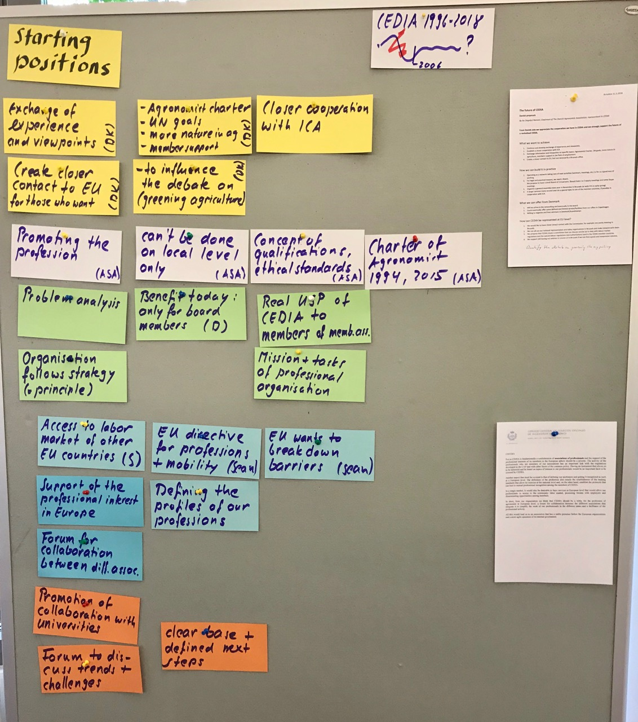
Proto 1: Every colour stands for the statements of a member association
Interpretation
- The starting positions expressed by the 5 member associations are not far apart.
- The following statements are shared:
  - Cedia members defend the interests of the professions in agriculture, food industry, forestry and all other branches of the bio-economy with a university education.
  - These professions need to be promoted on European level; it can’t be done successfully on national level only.
  - A good way to promote the interests of these professions on European level is the exchange of information on trends and needs with universities, multinational employers and the European Commission.
- The following statements may need further discussion:
  - Cedia should provide some services not only for the management (board members, secretarial staff) of Cedia members but also for their individual members.
  - Cedia should participate in the development and implementation of legislation for our professions and sectors at European level.

Vision & Mission
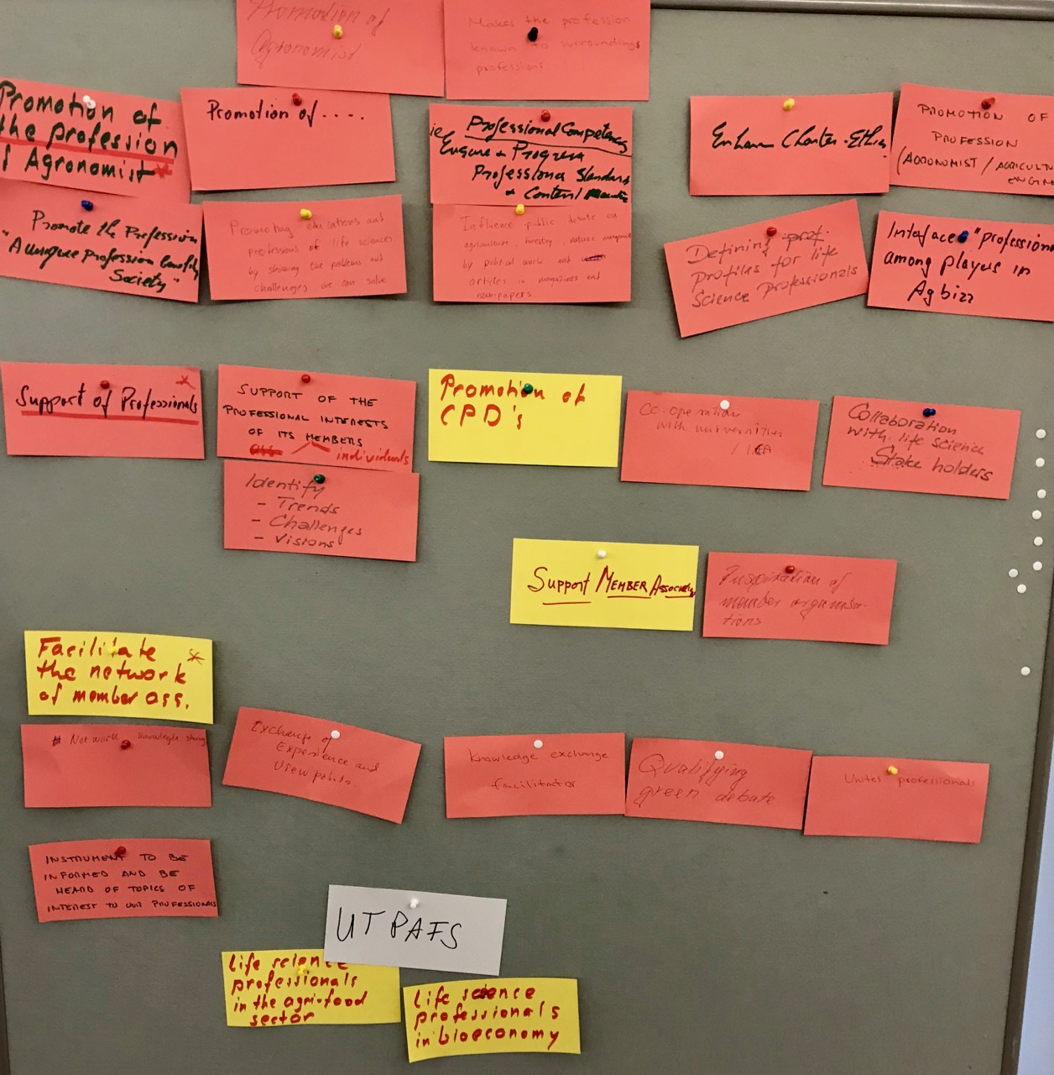
Proto 2: Participants expressed their propositions on cards

Transcription of the cards (from top left to the bottom right)
- Promotion of agronomist
- Makes the profession known to surrounding professions
- Promotion of the profession
- Promotion of …
- Professional competences, enhance & progress professional standards & content
- Enhance Charter Ethics
- Promotion of profession (agronomist, agricultural engineer)
- Promote the profession, unique profession in society
- Promoting profession of life sciences by showing the problems and challenges we can solve
- Influence public debate on agriculture, forestry, nature management by political work and articles in magazines and newspapers
- Defining profiles for life science professionals
- Interface “professionals” among players in Agbiss
- Support of professionals
- Support of the professional interests of its individual members
- Promotion of CPD’s (Remark: CPD = continuing professional development)
- Cooperation with universities / ICA
- Collaboration with life science stake holders
- Identify trends, challenges, visions
- Support Member Associations
- Inspiration of member organizations
- Facilitate the network of member associations
- Network, knowledge sharing
- Exchange of experience and viewpoints.
- Knowledge exchange, facilitator
- Qualifying green debate
- Unites professionals

Grouping of statements on the Cedia mission (draft)
- Promotion of the profession by defining general guidelines for the required academic education, skills and professional ethics in cooperation with universities and employers on European level
- Support of the national member associations by organizing the exchange of information, opinion and experience and on European level.
- Support of the professionals mainly through the national member associations

Mode of operation
According to the principle: Structure follows strategy, we started to design a mode of operation to fulfil the Cedia mission.
To facilitate the work, Rolf proposed the following model:
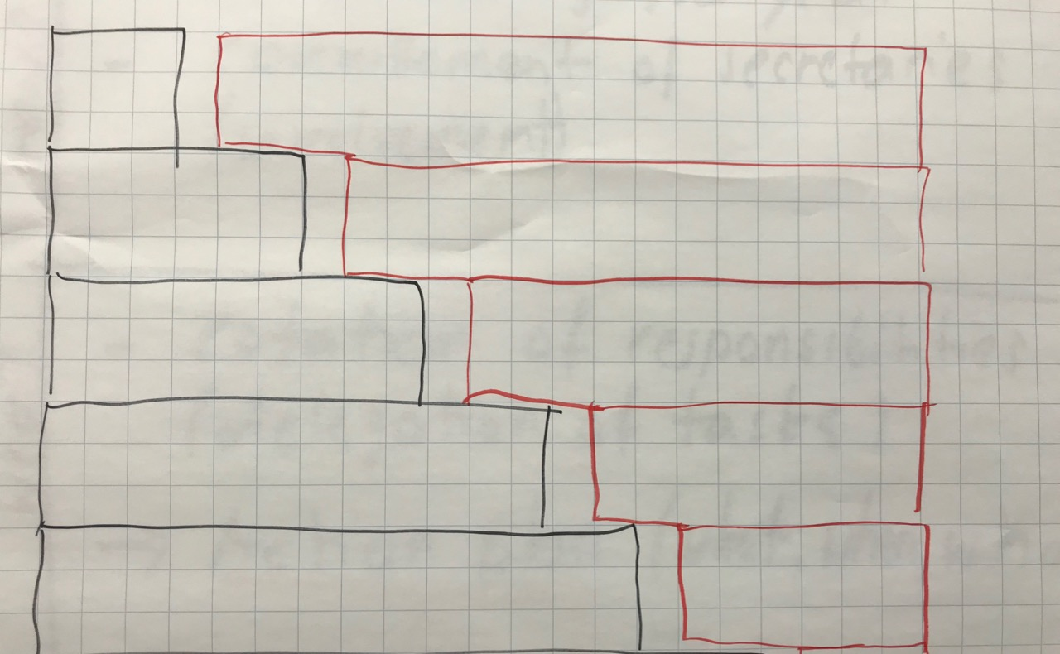
Photo 3: Left side: tasks, right side: organizational effort.
The more different tasks the more organizational effort it can take to get the jobs done.

Basic task: Facilitation of the network among member association
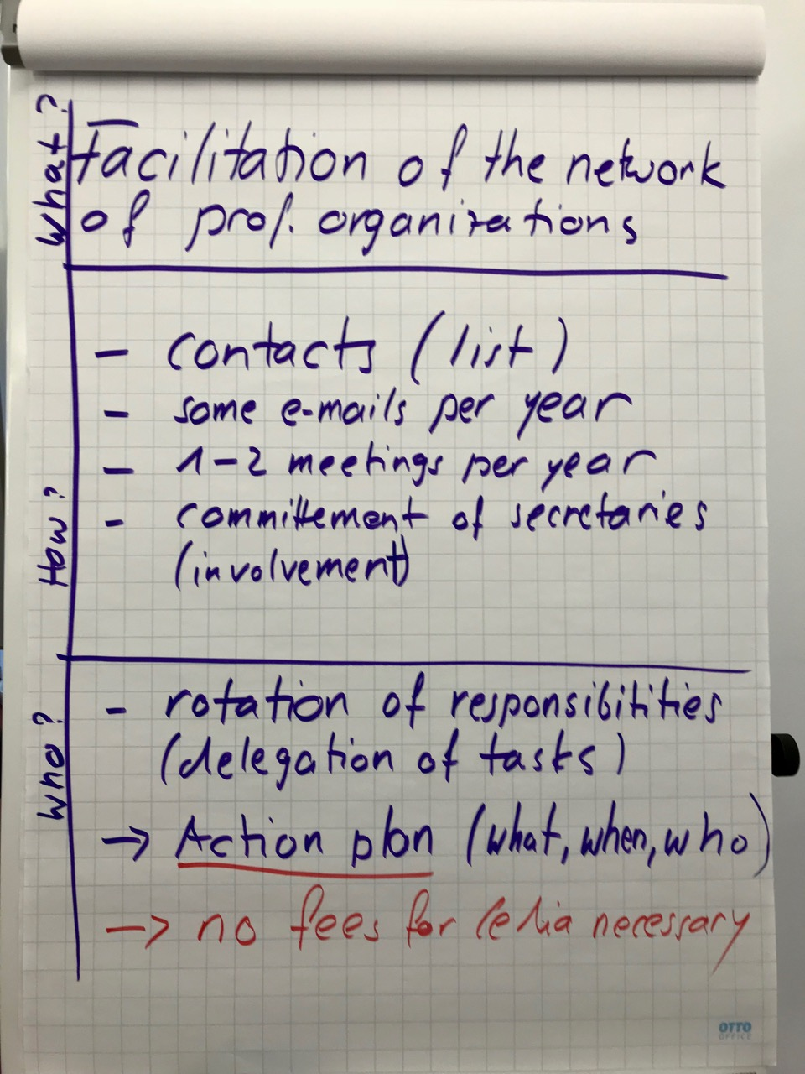
In order to facilitate the network among the member association as the basic task of Cedia not much organization is needed in order to assure the following services:
- Updating the membership list
- Sending some circular e-mails per year
- Organizing 1-2 meetings per year
All it would take is a small board of 3 persons with an acting, incoming and past president that is able to delegate the three tasks to member associations in a reliable way. This would be the case if the office of the organization concerned is committed to carry out the task.
If the meetings are used in well prepared way to work on the promotion of our profession on European level, Cedia could also fulfil its key mission with this typo of organization.

Next steps in the renewal process
- Review of these results by the participants of the workshop by July 30
- Finalization of this report by Sean Gaule (or Michel Roux) by August 10
- Sending this report to all member association by August 15
- Draft of a discussion paper on Cedia’s mission and mode of operation for the next general assembly of Cedia by September 30
- Discussion of Cedis’s mission and mode of operation at the next general assembly in October 2018 with the order to the board to update the statute
- Approval of the new statutes and election of the new board at the general assembly 2019

Access to workshop documentation and photos:
https://www.dropbox.com/sh/hzhzb0smhiurn1j/AACDbQdhHDXGQ_pgOwo1SLz8a?dl=0

Michel Roux, July 11, 2018

